Microsoft Excel Tutorial

Major League Baseball Team
Player | GP | AB | H | 1B | 2B | 3B | Homeruns | Walks | HBP | SF | AVG | SLG | OBP
Arraez, L | 9
Raley, L | 9
Rooker, B | 9
Sawyer, W | 9
Wade, L | 9
Cave, J | 8
Cesar, R | 8
Duda, L | 8

- Go to https://www.mlb.com/ and pick a team. Click on “Stats” and “Sortable Player Stats”. Create an Excel file similar to the one you see above:

You want 10 Players (1 being a pitcher), games played, at bats, hits, singles (create a formula using =hits-…), doubles, triples, homeruns, walks, hit by pitch, sacrifice fly. You also want a column for hitting average (using a formula), slugging percentage (using a formula) and on base percentage (using a formula).
*Note that each header on the website has an explanation of what the column shows/means.

- Highlight cells A2 – J2. With the cells highlighted right click and select Format Cells…
Click on the alignment tab and set the Orientation to 90 degrees. Set the Horizontal to Center and the Vertical to Bottom. Click OK, the labels should now be rotated and centered.

Note: To highlight multiple cells in a row or column, click on the first value, then hold control, shift and use the arrow keys to select the other values in the row/column.

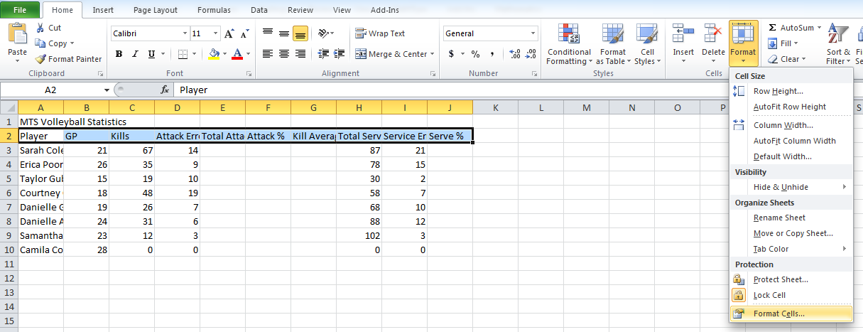

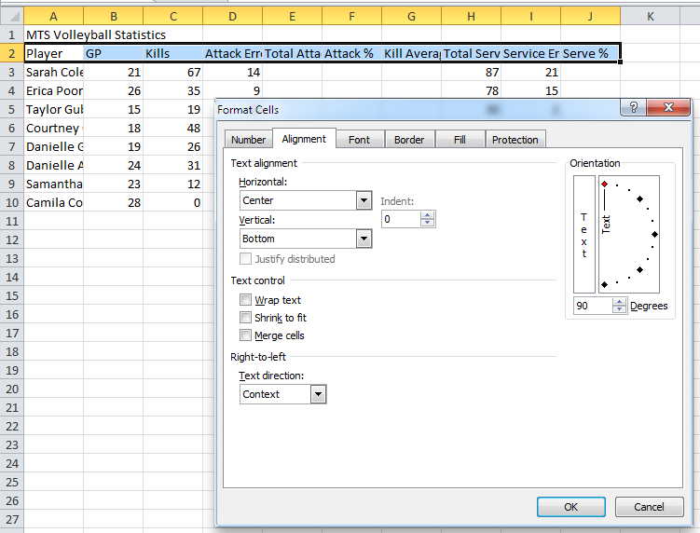

- Right click on the A in column A and change the width of column A to 20 (see screen shots below). Change the widths of column B to J to 5 (note: you can select all the columns at once by left clicking on B and dragging you mouse to J, then left click on any of the columns you selected).

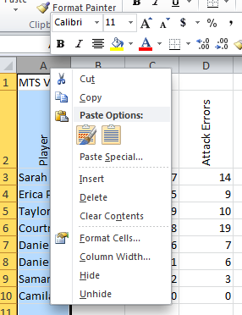 | 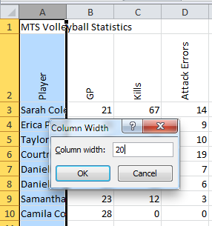

- Enter the formula for singles, average, slugging percentage, and on-base percentage.
- Copy the formula so that the calculations are made for each player

- Highlight the cells as shown to the right | 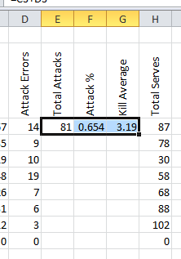 | - Click on the small square in the bottom right and drag to fill in the remaining cells as shown to the right. | 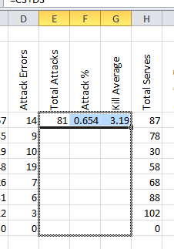

Your spreadsheet should now look like:
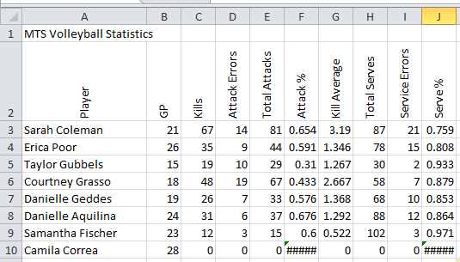

- Where you see ####### you will need to enter in a 0. Do you know why?
- In cells A12-A15 type: Totals, Min, Max and Average (see below).
- Do not fill in total, min, max, and average for columns if it doesn’t make mathematical sense to do so (ie meaningless information).
- In the Totals row determine the totals in cells B12, C12, D12, E12, G12, H12 and I12, using =SUM() formula. For example, you would type in B12 =SUM(B3:B10).
- In the Min row determine the minimum in cells B13 – J13, using =MIN() formula. For example, you would type in B13 =MIN(B3:B10).
- In the Max row determine the maximum in cells B14 – J14, using =MAX() formula. For example, you would type in B14 =MAX(B3:B10).
- In the Average row determine the average in cells B15 – J15, using =AVERAGE() formula. For example, you would type in B15 =AVERAGE(B3:B10).

Your spreadsheet should now look like:
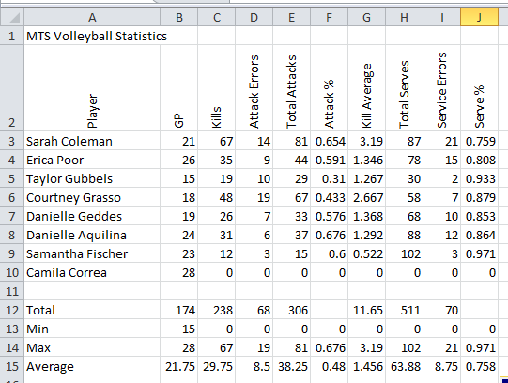

- Highlight cells A2 to J2, right click and select Format Cells…
Select the Fill tab and choose the turquoise colour, and select OK.
Repeat for cells A3 to A10 and A12 to A15.

- Highlight cells A2 to J10, right click and select Format Cells …
Select the Borders tab and choose Outline and Inside buttons under the presets, and select OK.
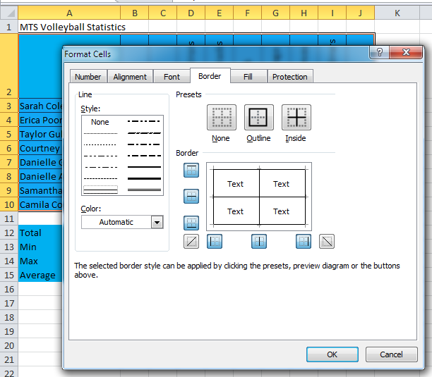

- Repeat for cells A12 – J15.
- Shade all the cells that contain number values to a light grey colour.
- Cells F12 and J12 will not be holding any information. Shade those two cells with a red colour.
- Highlight cells A1 – J1 and click the arrow on the Merge & Center button, then select Merge & Center.

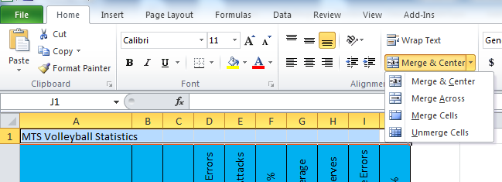

- Click on the title; add an outside border and set the background colour to yellow.
- Highlight cells A3 – J15 and center the data.

Your spreadsheet should now look like:
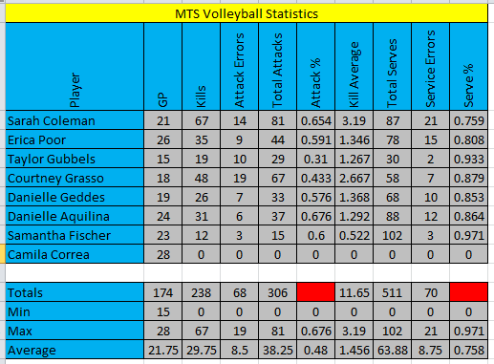

- In the bottom left hand corner of the sheet right click on the word Sheet 1 and select Rename Sheet…
Type the name: Tiger’s Baseball

- In the Page Layout tab, select Margins and set to Wide. Select Orientation and set to Landscape.

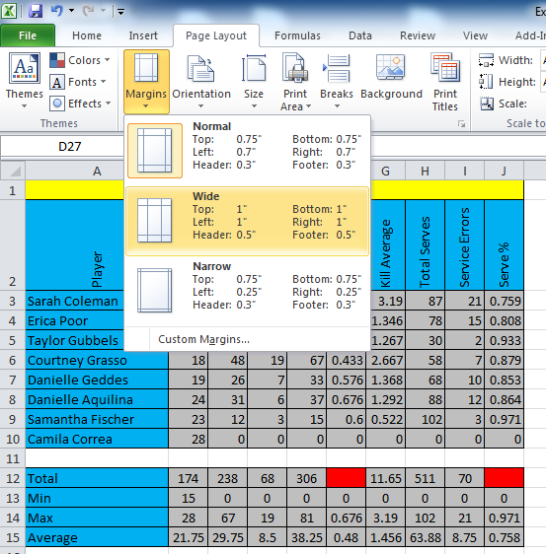 | 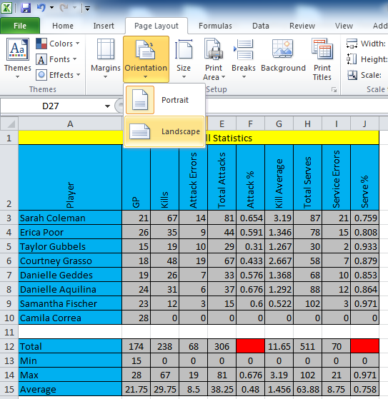

- Still under the Page Layout tab click on the small arrow beside Scale to Fit to open the Page Setup box.
Under the Margins tab check the Horizontally and Vertically boxes:

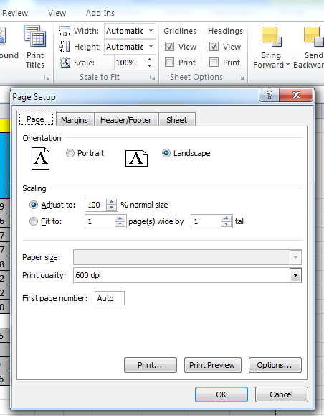 | 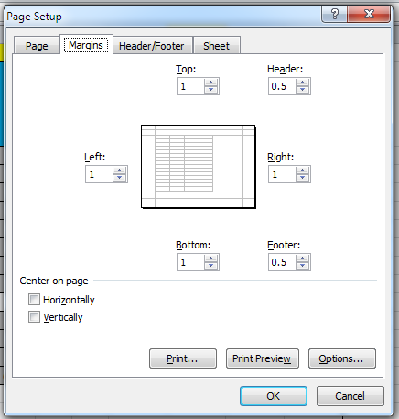

- Under the Header/Footer tab click on Custom Header… and complete the boxes as indicated (Use your last name and today’s date):

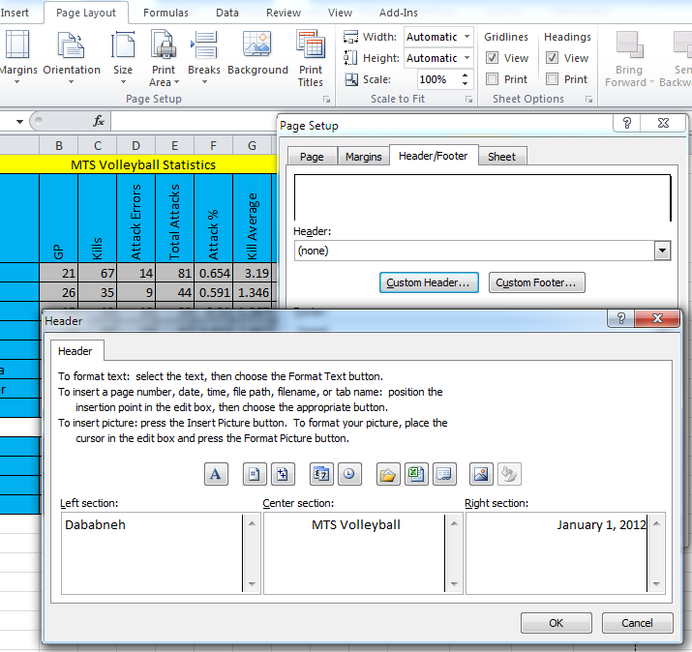

- Create a Custom Footer… with the Center section: MS Excel Tutorial
- Click on File tab, and select print and you should see the following:

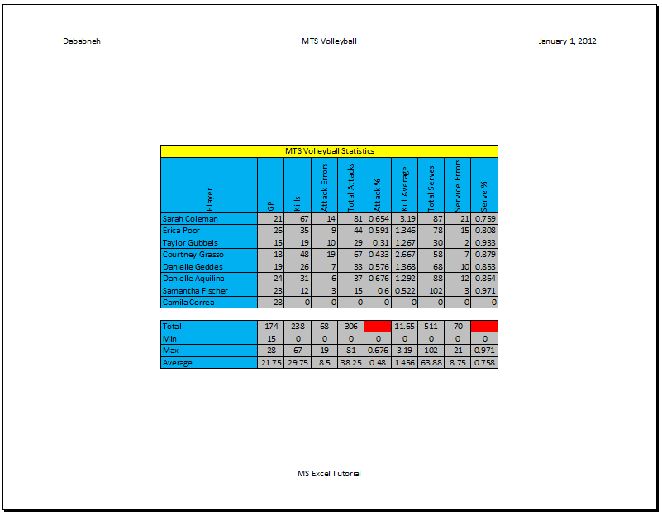

- Save this file as lastname_firstinitial_excel_intro (for example reati_m_excel_intro) in your student drive, and then put it in d2l dropbox.

- ***Make sure to ask if I received your assignment!

